TVS SDE Commercial Research Advisory Committee (CRAC) - Terms of Reference (ToR)

Revision history
0.1 | First draft | GR, FK
0.2 | Updated draft | GR, FK
0.3 | Updated draft | GR, FK, RA
0.4 | Updated draft | GR, FK, SD

About this document
This document defines the scope, objectives, and role of The Thames Valley and Surrey Secure Data Environment (TVS SDE) Commercial Research Advisory Committee (CRAC). It serves as a guide for members and observers to understand their responsibilities, set expectations, and agree ways of working.
This document is presented in draft form. It will be approved upon review and agreement with the CRAC.

Purpose
The TVS SDE Commercial Research Advisory Committee is the key forum for commercial stakeholders and management to discuss, review and guide the direction of development, sustainability, and use of the TVS SDE for collaborative commercial research purposes. As well as driving the development and delivery of services that are most useful to the commercial community, this group will help prepare customers for changes to existing governance processes, thus optimising their interaction with the SDE. Finally, members will support the realisation of TVS SDE benefits as set out by the TVS SDE Board to all stakeholders.

Aims and responsibilities
The CRAC will:
- facilitate communication and collaboration between the TVS SDE and its commercial stakeholders.
- provide advice and guidance to the TVS SDE regarding the commercial stakeholders' strategic needs and service development priorities.
- represent the diversity of commercial interests and stages (e.g., Startup, Spin Out, SME, Established, Global).
- advise on alignment of governance processes for efficient data request and access for commercial use cases.
- raise awareness of the TVS SDE within the commercial community
- identify internal champions to promote and support maximising the impact of the TVS SDE
- Liaise with R&D funders and charitable bodies to ensure TVS SDE costs can be included in funding awards.
- support TVS SDE to promote collaboration with other SDEs and the SDE Southern Consortium (SoCo) in particular.
- represent the TVS SDE commercial stakeholders in the national context.
- promote collaborative opportunities for health data research initiatives (for example, around particular clinical specialities or disease themes).
- provide feedback and constructive advice on SDE Operations, Process and Environment – for example software requirements, user interface designs, governance flows and user experience considerations.

N.B. CRAC will not form part of the selection and approval processes for data requests.

Membership
The CRAC comprises the following individuals:
Role | Function
Commercial representatives | Representing commercial perspectives (see appendix one)
Commercial lead, TVS SDE | Representing commercial perspective for the TVS SDE programme
Health Innovation Networks representative | Representing the TVS SDE region
PPIE lead, TVS SDE | With responsibility for patient and public involvement, engagement, and experience
Public Member(s) | Representing the patient and public perspective
Health & Care Member(s) | representing a range of professional backgrounds across different sectors within their geographical area
Director, TVS SDE | Representing the TVS SDE programme
Project Support Manager, TVS SDE | Minutes, secretariat (non-voting)

For the first six months the TVS SDE Commercial Lead will act as interim chair. The committee shall then nominate a chair for future meetings. The committee Chair will be ratified by the TVS SDE Programme Board. The Chair position is for a maximum period of 24 months. Changes to the Chair position shall follow the same process.

If a member is unable to attend a given meeting, they will be asked to nominate a suitable deputy from their organisation, who can attend in their place.

Observers may be invited to attend the meeting when appropriate. Such attendees are not counted as part of the quorum.

Any of the following may be asked to attend:
- representative of the TVS SDE operational teams e.g. service, technical, commercials and finance, governance and engagement
- scientific, technical, legal, or governance experts
- representative from the TVS SDE academic research advisory committee
- representatives from the Integrated Care Systems (ICSs) and / or partner trusts

The Committee shall be quorate if at least six members are present and must include two commercial representatives, the chair, the TVS SDE Commercial Lead, and the TVS SDE Director or their nominated deputy.

Accountabilities
The committee is accountable to the TVS SDE Management Team.

Review
The committee shall review this ToR annually, and if there is a major change in the programme.
The membership will be reviewed periodically to ensure it remains representative and relevant to the aims and responsibilities.

Ways of working
The committee shall meet every three months either in person or via videoconference. Decisions can be made outside committee at discretion of the chair with a quorate number of members. Where appropriate, subgroups may be convened to complete discrete work packages and report back.
In practical terms, methods of working will mean:
- Considering a wide perspective across the commercial landscape, and not just as a representative of your own organisation.
- Where members cannot attend the meeting, they should inform the secretariat and arrange for a suitably empowered deputy to attend.
- Observers, including other programme staff, may join the meeting from time to time and in agreement with the chair
- Agenda items for discussion will be defined by the members using on a standard agenda template, plus any matters arising
- Any meeting papers shall be distributed electronically at least three working days before the meeting.
- Committee members are required to comply with the TVS SDE policy on declaring and managing interests.
- Committee members are required to ensure commercially sensitive information is kept confidential and to sign a non-disclosure agreement to this effect.

Appendix one: List of commercial organisations in scope

Company
Aneira Health Limited
Arturis Data (UK) Limited
Boehringer Ingelheim Limited
Cancer Research Technology Limited, trading as Cancer Research Horizons
Clarivate PLC
Diaceutics PLC
Ferring Pharmaceuticals Limited
Johnson & Johnson Limited
LifeArc
Oxford Cancer Analytics Limited
Oxford Science Enterprises plc
Promptly Health LDA
Proxemis Limited
RAIQC Limited
Roche Diagnostics Limited

Appendix two: programme organisation

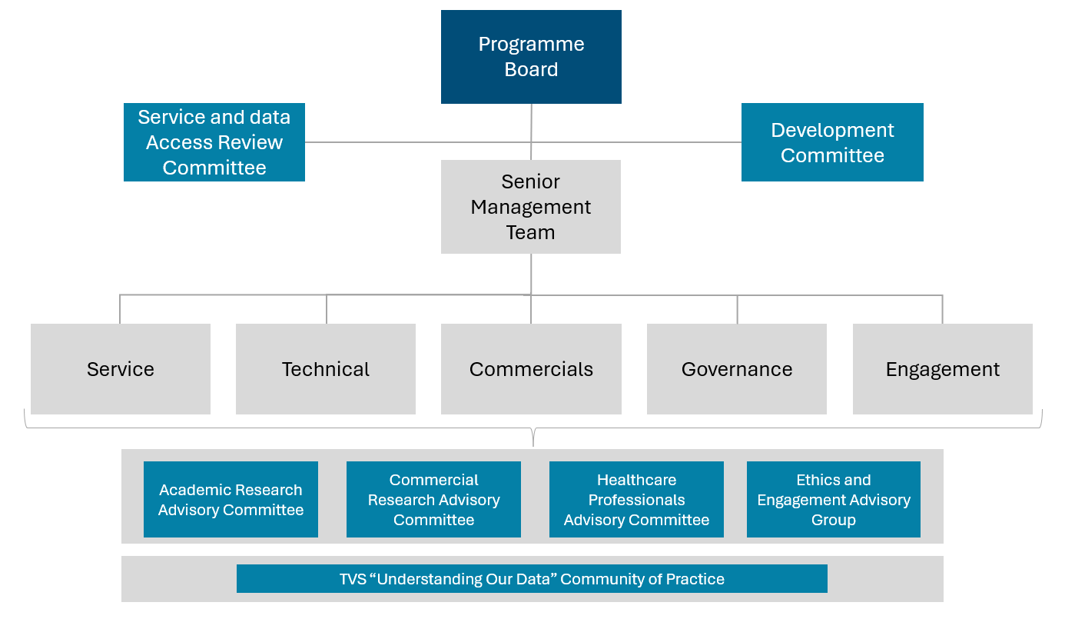
Figure 1 – programme organisation chart

