Role description: Independent advisors for

Thames Valley & Surrey Secure Data Environment (TVS SDE)

Background
Information about patients is collected and used by the NHS to:
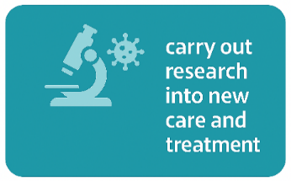
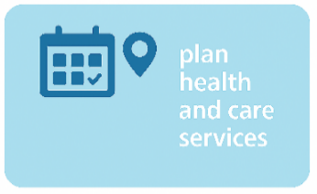
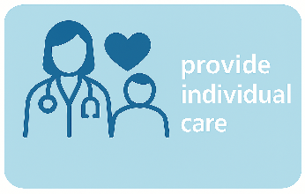

To support research and analysis, the NHS has established a network of Secure Data Environments (SDEs). SDEs provide secure storage for health and care data. People, like university or industry researchers, can apply to become approved users to access this data. The data they can see is agreed before they are given access. The data does not leave the NHS. See our website for further information.

What is happening locally?
Across the Thames Valley and Surrey we have established an SDE (TVS SDE). The SDE covers the geography shown in figure 1. The SDE has a number of committees that support its safe and effective development and running.
We are looking for three independent advisors to sit on our Services and data Access Review Committee (SARC) to provide advice on matters relating to ethics, information governance (IG) and research and development (R&D).
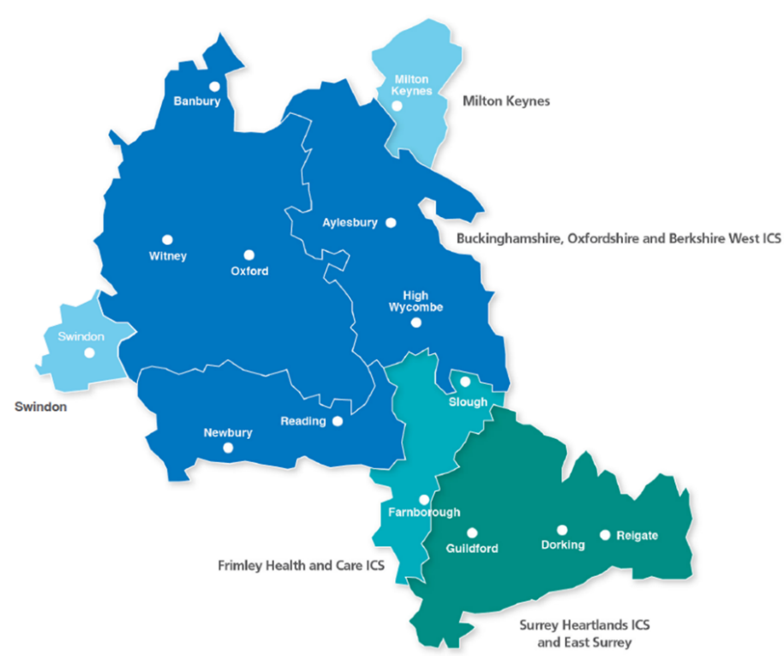

Figure 1: Map showing areas covered by TVS SDE

The Services and data Access Review Committee (SARC)
The TVS SDE is governed and supported by a number of committees which include both health & care members and public members.

The role of the SARC is to:

- set policy relating to data held by the TVS SDE;
- assess and determine the outcome of applications for access to data held in the TVS SDE;
- agree the appropriate controls that are required for any approved applications.

Further information can be found in the TVS SDE SARC Terms of Reference here.

We are looking to recruit three independent advisors to support the work of the TVS SDE by sitting on the SARC and advising on matters relating to ethics, information governance (IG) and research and development (R&D).

What is an independent advisor and why do we need them?
Independent advisors play a crucial, impartial role in ensuring that sensitive health and care data is handled ethically, lawfully, and in line with public expectations. They act as "critical friends" to organisations, providing scrutiny on data policies and technology deployment while safeguarding privacy. Your role on the committee would strictly be in an advisory capacity, you would not be a voting member.

Roles and responsibilities
By areas of expertise
Ethics
- Check applications to help ensure they are genuinely in the public interest and will benefit patients and the NHS.
- Highlight any ethical concerns, such as data bias, privacy issues, or impacts on under-represented groups.
- Help ensure the use of sensitive health and care data is transparent and trustworthy.

Information Governance (IG)
- Check whether projects follow UK GDPR, the Five Safes, and the Caldicott Principles.
- Advise on whether the data being used is minimised appropriately and whether the security controls (like de-identifying data) are suitable.
- Support the development of policies that guide how data in the SDE is managed and protected.

Research & Development (R&D)
- Help to determine whether project applications are scientifically sound and workable.
- Provide advice on using different types of data (such as letters, images, or genomic data) in the right way.
- Guide how clinical algorithms and new data-driven tools could be tested and validated.

Overarching roles and responsibilities
- Provide critical professional challenge.
- Consider the perspectives of stakeholder/data controller views from across TVS and not just represent your own perspective.
- Support awareness of the TVS SDE programme and its work.
- Review and comment on documentation.
- Comply with the Terms of Reference set out by SARC.

Skills and experience
The following attributes, skills and experience are desirable:

- Proven expertise in ethics, law, information governance, or health and care data.
- Experience of committee work.
- The ability to provide constructive challenge e.g. exploring what has worked well, what could be even better and what can be learnt.
- The ability to interact with a wide range of people, understand what matters to them and listen to their views.
- A commitment to openness, equality, diversity and inclusion.
- The ability to understand and discuss complex issues, including value and ethical considerations.
- An interest in health services and data.
- Self-motivation and organisation.
- Sound judgement and objectivity.
- Understanding the need for confidentiality.

Independent advisors will be drawn from a range of professional backgrounds, sectors and geographical areas. Members are not being asked to represent the whole of the communities/professional groups that they come from.

Time commitment
- The appointment will be for one year in the first instance, with a review after two meetings.
- The SARC meets monthly for 1.5 hours.
- Meetings are currently held online via MS Team, however there will be at least one SARC meeting a year in person.
- Papers will be sent by email in advance of the meetings, and advisors will be expected to review the papers in advance of the meeting.
- Preparation time for each meeting is likely to be one hour.
- There is an expectation that advisors will attend a minimum of 80% of SARC meetings.
- There may be occassions where your advice is requested between meetings.
- A half day, in person, induction will be mandatory and will take place in early summer.

How to apply
If you are interested in applying, please complete the separate application form and email it to Lisa-Anne Dallas at TVSSDE@ouh.nhs.uk.

As part of your application, you will be asked to provide details of one referee (there is an advantage to this being your line manager as you will need to confirm that you have the time agreed before application). Please also complete and return a diversity monitoring form.

Closing date for applications: Friday 5th June 2026 at 17.00
Online interview dates: Tuesday 16th and Wednesday 17th June 2026

If you have any questions about the role, please email TVSSDE@ouh.nhs.uk.

