Role description: Primary care member for

Thames Valley & Surrey Secure Data Environment (TVS SDE) Services and data Access Review Committee (SARC)

Background
Information about patients is collected and used by the NHS to:
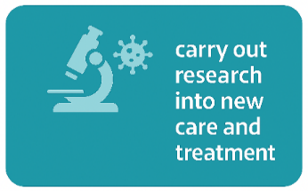



To support research and analysis, the NHS has established a network of Secure Data Environments (SDEs). SDEs provide secure storage for health and care data. People, like university or industry researchers, can apply to become approved users to access this data. The data they can see is agreed before they are given access. The data does not leave the NHS. See our website for further information.

What is happening locally?
Across the Thames Valley and Surrey we have established an SDE (TVS SDE). The SDE covers the geography shown in figure 1. The SDE has a number of committees which include both health and care members and public members, that support its safe and effective development and running.
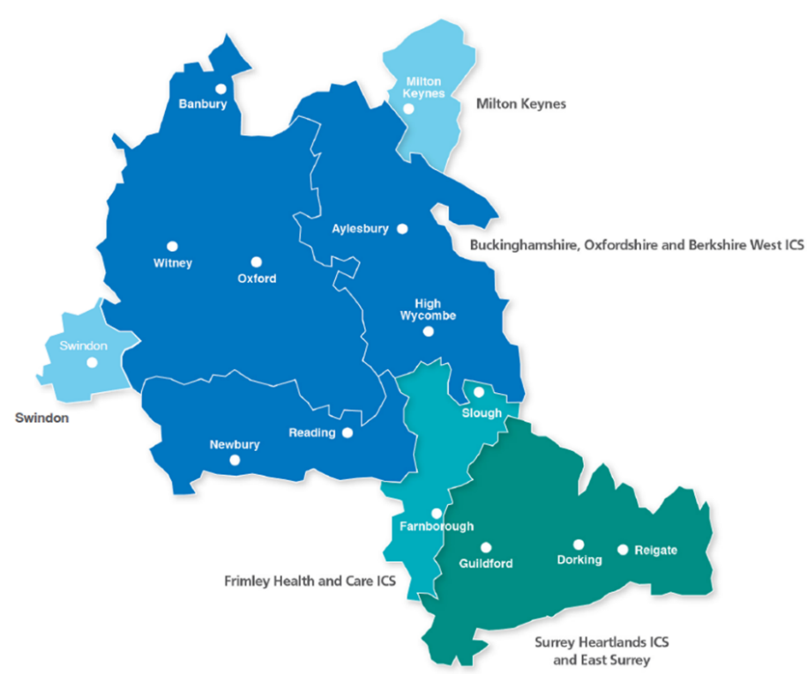

Figure 1: Map showing areas covered by TVS SDE

The Services and data Access Review Committee (SARC)
The role of the SARC is to:

- set policy relating to data held by the TVS SDE;
- assess and determine the outcome of applications for access to data held in the TVS SDE;
- agree the appropriate controls that are required for any approved applications.

Further information can be found in the TVS SDE SARC Terms of Reference here.

We are looking for a primary care member to sit alongside other health and care staff, and public members, on the SARC to support the work of the TVS SDE.

What is a primary care member and why do we need one?
The SARC includes members from a wide range of health and care backgrounds and sectors, enabling the Committee to benefit from diverse professional perspectives. To strengthen perspectives from key sectors and ensure a broader range of expertise, we are seeking to recruit a member working in primary care within the TVS SDE footprint.

The member would help ensure that the perspectives of primary care are appropriately considered when researchers request access to data within TVS SDE. The primary care member would have voting rights, with direct influence over decisions on research access to SDE data.

Roles and responsibilities
- Provide critical professional challenge.
- Consider the perspectives of stakeholder/data controller views from across TVS and not just represent your own perspective.
- Support awareness of the TVS SDE programme and its work.
- Review and comment on documentation.
- Comply with the Terms of Reference set out by the SARC.

Skills and experience
The following attributes, skills and experience are desirable:

- Experience of committee work.
- The ability to provide constructive challenge e.g. exploring what has worked well, what could be even better and what can be learnt.
- The ability to interact with a wide range of people, understand what matters to them and listen to their views.
- A commitment to openness, equality, diversity and inclusion.
- The ability to understand and discuss complex issues, including value and ethical considerations.
- An interest in health services and data.
- Self-motivation and organisation.
- Sound judgement and objectivity.
- Understanding the need for confidentiality.

The primary care member can come from a range of professional backgrounds within the primary care sector. The member is not being asked to formally represent the range of potential views from their professional background or for all primary care.

Time commitment
- The appointment will be for one year in the first instance, with a review after two meetings.
- The SARC meets monthly for 1.5 hours.
- Meetings are currently held online via MS Team, however there will be at least one SARC meeting a year in person.
- Papers will be sent by email in advance of the meetings, and advisors will be expected to review the papers in advance of the meeting.
- Preparation time for each meeting is likely to be one hour.
- There is an expectation that advisors will attend a minimum of 80% of the SARC meetings.
- There may be occassions where your advice is requested between meetings.
- A half day, in person, induction will be mandatory and will take place in early summer.

Renumeration
Primary care members will be reimbursed at a rate of £200 per SARC meeting. This includes reading/meeting preparation and attending the meeting.

How to apply
If you are interested in applying, please complete the separate application form and email it to Lisa-Anne Dallas at TVSSDE@ouh.nhs.uk.

As part of your application, you will be asked to provide details of one referee (there is an advantage to this being your line manager as you will need to confirm that you have the time agreed before application). Please also complete and return a diversity monitoring form.

Closing date for applications: Friday 5th June 2026 at 17.00
Online interview dates: Tuesday 16th and Wednesday 17th June 2026

If you have any questions about the role, please email TVSSDE@ouh.nhs.uk.

